***Department of Computer Science,***

***Punjabi University, Patiala-147 002***

***Registration of Students for Final Semester Project***

|  |  |  |  |
| --- | --- | --- | --- |
|  | **Class** | **:** | M.C.A 3rd |
|  | **Roll Number** | **:** |  |
|  | **Name** | **:** |  |
|  | **Correspondence Address** | **:** |  |
|  | **Project Title** | **:** |  |
|  | **Name of the Organization** | **:** |  |
|  | **Organization Address** | **:** |  |
|  | **Name & Designation of External Project Guide** | **:** |  |
|  | **Qualification** | **:** |  |
|  | **Date of Joining** | **:** |  |
|  | **Project Description**  (not more than 20 lines) | **:** |  |
|  |  |  |  |
|  | **Software Platform**  **(**Operating System/Packages/Languages/Tools/Protocols used) | **:** |  |
|  | **Hardware Platform** | **:** |  |

**Vidya Publications**

**Project Report**

**submitted**

**in the partial fulfillment**

**for the award of degree of**

**Master of Computer Applications**

**(2017-2020)**

***Submitted by***

***Ashish Bindra***

***Under Supervision of***

***Name of the Teacher***

***Designation,***

***Department of Computer Science***

***Punjabi University, Patiala***



***Department of Computer Science,***

***Punjabi University, Patiala - 147 002***

***May 15, 2020***

Letter Head of the Department of Computer Science

**Dated: dd-mm-yyyy**

***CANDIDATE DECLARATION***

This is to certify that the project entitled____________________ is my own work, carried out in ____________ organization from ______ to _____ , under the external guidance of ___________ and internal supervision of __________.

(Name of Student)

***CERTIFICATE***

It is certified that the project entitled _______________ is submitted in partial fulfillment of the requirement for the degree of Master of Computer Applications in the Department of Computer Science, Punjabi University, Patiala. This work has been done by ____________, a bonafide student of the Department.

This work is fit for the consideration of award of the said degree to her/him.

**(Name*)***

Internal Supervisor(s)

Counter Signed

**(*Name)***

Training in Charge

**(*Name*)**

Head of the Department

**TABLE OF CONTENTS**

|  |  |  |
| --- | --- | --- |
| SR. No. | DESCRIPTION | PAGE NO. |
| 01. | INTRODUCTION | 3 |
| 02. | OBJECTIVES OF THE PROJECT WORK | 4 |
| 03. | SYSTEM REQUIREMENT SPECIFICATION DOCUMENT | 5 |
| 04. | DESIGN DOCUMENTS   * 1. SYSTEM DESIGN   2. DATA BASE DESIGN   3. USER INTERFACE | 6 |
| 05. | FEATURES OF LANGUAGE/PLATFORM | 7-39 |
| 06. | IMPLEMENTATION RESULTS AND TESTING | 40-41 |
| 07. | FUTURE SCOPE | 42-53 |
| 08. | APPENDICES   * 1. REFERENCES   8.2 SOURCE CODE LISTING | 54 |

**INTRODUCTIOM**

Vidya Publications is an independent publisher specializing in the publication of high-impact journals, proceedings and books, in both printed and online versions, across all areas of engineering, science, humanities, arts etc. We are aiming to the leading scientific publisher and publish an expanding academic research content programme.

A journal, from the [Old French](https://en.wikipedia.org/wiki/Old_French) journal (meaning "daily"), may refer to several things. In its original meaning, it refers to a daily [record](https://en.wikipedia.org/wiki/Record_(disambiguation)) of activities, but the term has evolved to mean any record of activities, regardless of time elapsed between entries, such as a

* [Diary](https://en.wikipedia.org/wiki/Diary), a record of what happened over the course of a day or other period
* [Daybook](https://en.wikipedia.org/wiki/Daybook), also known as general journal, a daily record of financial transactions
* [Logbook](https://en.wikipedia.org/wiki/Logbook), a record of events important to the operation of a vehicle, facility, or otherwise
* [Transaction journal](https://en.wikipedia.org/wiki/Transaction_log), a chronological record of data processing

**AIM OF THE JOURNAL**

The main aim of the journal is to provide a platform to researchers from Engineering Streams (Computer / I.T., Mechanical and Electronics) to present their high quality research work and innovation in the form original, unpublished research paper

**Overview of website**

Vidya publication is used for users they can see list of journal, and its details & they can also see latest journal news, and there is post issue and some special issue after that they can also register for author, After registration User can submit their own paper and publish it But it all depends on user’s paper reviewer, if he/she can decline user's paper than he/she(reviewer) is not satisfied by it.

**Research Cell:** International Journal of Engineering Sciences ethic statements are based on the Best Practice Guidelines for Journal Editors developed by Editor and Associate Editors

**Duties of Editors**

**Publication decisions** The editor of RC: IJOES is responsible for deciding which of the articles submitted to the journal should be published. The editor may be guided by the policies of the journal's editorial board. The duties of the editor are also to send the plagiarism reports and other such issues to the authors of the concerned articles and will not publish. The editor may confer with other editors or reviewers in making this decision.

**Fair policy** An editor and associate editors should evaluate manuscripts for their intellectual content without regard to race, gender, sexual orientation, religious belief, ethnic origin, citizenship, or political philosophy of the authors.

**Confidentiality** The editor and any editorial staff must not disclose any information about a submitted manuscript to anyone other than the corresponding author, reviewers, potential reviewers, other editorial advisers, and the publisher, as appropriate.

**Disclosure and conflicts of interest** Unpublished materials disclosed in a submitted manuscript must not be used in an editor's own research without the express written consent of the author.

**Duties of Reviewers**

**Contribution to Editorial Decisions**

Peer review assists the editor in making editorial decisions and through the editorial communications with the author may also assist the author in improving the paper. **Promptness** Any selected referee who feels unqualified to review the research reported in a manuscript or knows that its prompt review will be impossible should notify the editor and excuse himself from the review process.

**Confidentiality** Any manuscripts received for review must be treated as confidential documents. They must not be shown to or discussed with others except as authorized by the editor.

**Standards of Objectivity** Reviews should be conducted objectively. Personal criticism of the author is inappropriate. Referees should express their views clearly with supporting arguments.

**Acknowledgement of Sources** Reviewers should identify relevant published work that has not been cited by the authors. Any statement that an observation, derivation, or argument had been previously reported should be accompanied by the relevant citation. A reviewer should also call to the editor's attention any substantial similarity or overlap between the manuscript under consideration and any other published paper of which they have personal knowledge.

**Disclosure and Conflict of Interest** Privileged information or ideas obtained through peer review must be kept confidential and not used for personal advantage. Reviewers should not consider manuscripts in which they have conflicts of interest resulting from competitive, collaborative, or other relationships or connections with any of the authors, companies, or institutions connected to the papers.

**Duties of Authors**

**Reporting standards** Authors of reports of original research should present an accurate account of the work performed as well as an objective discussion of its significance. Underlying data should be represented accurately in the paper. A paper should contain sufficient detail and references to permit others to replicate the work. Fraudulent or knowingly inaccurate statements constitute unethical behaviour and are unacceptable.

**Data Access and Retention** Authors are asked to provide the raw data in connection with a paper for editorial review, and should be prepared to provide public access to such data and should in any event be prepared to retain such data for a reasonable time after publication.

**Originality and Plagiarism** Authors should ensure that submitted work is original and has not been published elsewhere in any language, and if the authors have used the work and/or words of others that this has been appropriately cited or quoted. Applicable copyright laws and conventions should be followed. Copyright material (e.g. tables, figures or extensive quotations) should be reproduced only with appropriate permission and acknowledgement. The authors are submitting other work in any form (tables, figures, text, benchmarks, and observations/conclusions) are liable for the legal actions.

**Multiple, Redundant or Concurrent Publication** An author should not in general publish manuscripts describing essentially the same research in more than one journal or primary publication. Submitting the same manuscript to more than one journal concurrently constitutes unethical publishing behaviour and is unacceptable.

**Acknowledgement of Sources** Proper acknowledgment of the work of others must always be given. Authors should cite publications that have been influential in determining the nature of the reported work.

**Authorship of the Paper** Authorship should be limited to those who have made a significant contribution to the conception, design, execution, or interpretation of the reported study. All those who have made significant contributions should be listed as co-authors. Where there are others who have participated in certain substantive aspects of the research project, they should be acknowledged or listed as contributors. The corresponding author should ensure that all appropriate co-authors and no inappropriate co-authors are included on the paper, and that all co-authors have seen and approved the final version of the paper and have agreed to its submission for publication.

**Disclosure and Conflicts of Interest** All authors should disclose in their manuscript any financial or other substantive conflict of interest that might be construed to influence the results or interpretation of their manuscript. All sources of financial support for the project should be disclosed. Fundamental errors in published works .When an author discovers a significant error or inaccuracy in his/her own published work, it is the author’s obligation to promptly notify the journal editor or publisher and cooperate with the editor to retract or correct the paper.

**OBJECTIVES OF THE PROJECT WORK**

The main object is that it is helpful for Punjabi university so that Punjabi university student or faculty need not to look around any other website so we have our own website we can set policy our own and by using this project can easily take seminar and give some other to involve it and can earn money.

**To make knowledge about the quality and effectiveness of various interventions available**

We know from a large number of studies that the quality and effects of many interventions used in practice are uncertain. At the same time, there are interventions with solid documentation from research that, nonetheless, are not put to use in practice. Most professionals have limited time to keep updated on all the research literature and need a relevant summary of research results in order to include research-based knowledge in their practice. Assessment of quality and effects tied to an intervention will provide professionals, researchers and decision-makers with information on whether the intervention fulfils its purpose and whether it may be implemented in practice.

**To stimulate further research on the effects of interventions**

Child and youth services and agencies in Norway would like to offer methods that they have reason to believe fulfil their intentions. More studies on the effectiveness of different interventions will make this easier. Therefore, the criteria for classification are designed to inspire further research on the effects of interventions. Many of the interventions are currently under development, and studies are being conducted or planned to evaluate the effectiveness. The requirements for the various levels of evidence are thus built on each other such that new and improved documentation may lead to a higher classification for the intervention.

**To contribute to an overview of areas that lack interventions documented as effective**

The journal Unison provides an overview of the areas where there are well-documented interventions available in Norway and where there are knowledge gaps. This overview may provide the basis for recommendations on the development of new interventions in areas where they are currently not found.

**SYSTEM REQUIREMENT SPECIFICATION DOCUMENT**

**TECHNOLOGY USED**

It is a web based environment with PHP 7 as the server side scripting language with MVC, and PHP Data Objects (PDO) as the relational DBMS and JavaScript is used for client side scripting Ajax is used for real time change in front end. Clients will be Google Chrome based. Mozilla Firefox etc can also be used. All front-end design is done using PHP with JavaScript, jquery, bootstrap, HTML5, Cascading Style Sheets (CSS) and Bootstrap.

[Internet Technologies: JavaScript, HTML5, jquery

PHP 5.6.25 and Apache Server (WAMP) or xampp

RDBMS/Back End: PDO]

**REQUIREMENTS**

**Software requirements**

* WAMP Server
* Git
* Notepad ++, VS code, Sublime 3
* Browsers (Google Chrome/ Mozilla Firefox)

**Hardware requirements**

* Intel Duel Core 2.0GHz or higher processor
* 2 GB RAM
* 10 GB HDD Space

**DESIGN DOCUMENTS**

**SYSTEM DESIGN**

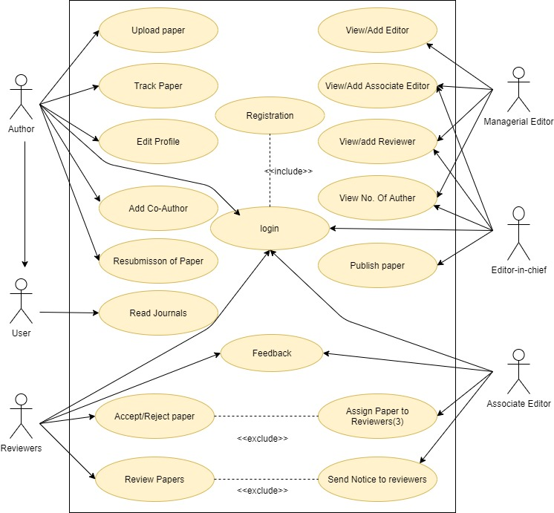

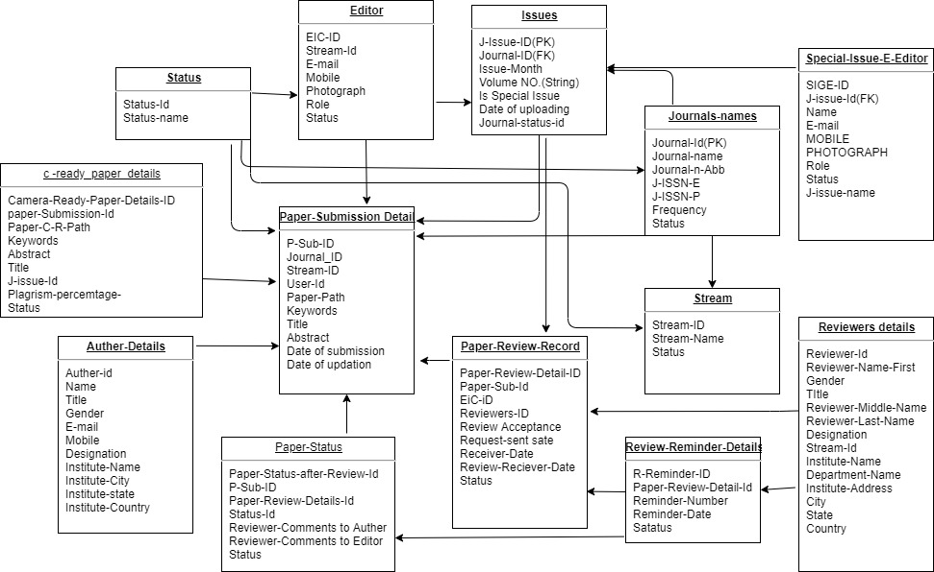

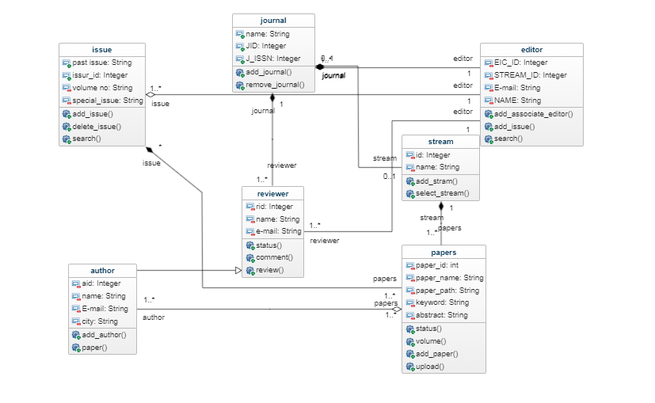

**FEASIBILITY STUDY**

The main aim of the feasibility study activity is to determine whether it would be financially and technically feasible to develop the project. It involves analysis of the problem and collection of all relevant information.

After collecting all the relevant information (like who are the users, how they interact with the system etc) and details about our project “**Online Journal Research**” we reach at the conclusion that the system is financially feasible and can be developed using the technology that we presently have. It helps to get lot of author from the university.